In this assignment, you are tasked with creating Kubernetes deployment files and a HELM chart for a MERN (MongoDB, Express.js, React.js, Node.js) based application. The provided project consists of separate frontend (FE) and backend (BE) components.
You will need to:
Develop Kubernetes deployment files for both frontend and backend components, ensuring seamless deployment and scalability.
Create a HELM chart to streamline the deployment process, allowing for easy configuration and management.
Write Jenkins Groovy code to automate the build and deployment process, ensuring consistency and efficiency in your CI/CD pipeline.
The provided GitHub repositories contain the frontend and backend codebases, which you will use as the basis for your deployment configurations.
    - https://github.com/UnpredictablePrashant/learnerReportCS_frontend
    - https://github.com/UnpredictablePrashant/learnerReportCS_backend
Please ensure to document your process thoroughly, including any challenges faced and solutions implemented. Your submission should demonstrate your understanding of Kubernetes deployment, HELM charts, and Jenkins automation in the context of a MERN stack application.

Instead of this we have used shop now
forked the repository from- https://github.com/aryanm12/shopNow

Kubernetes:-
Backend: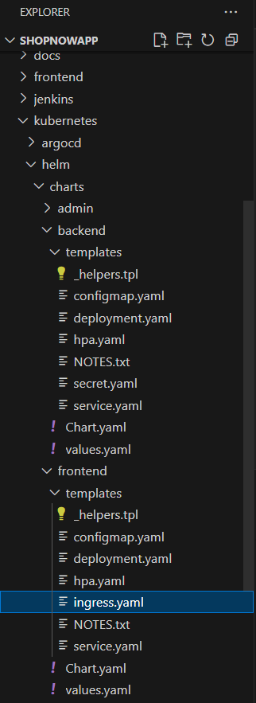

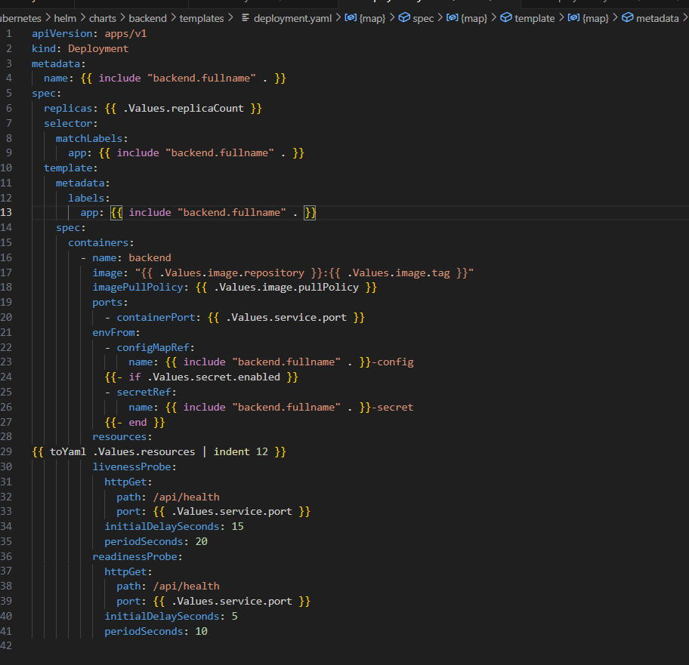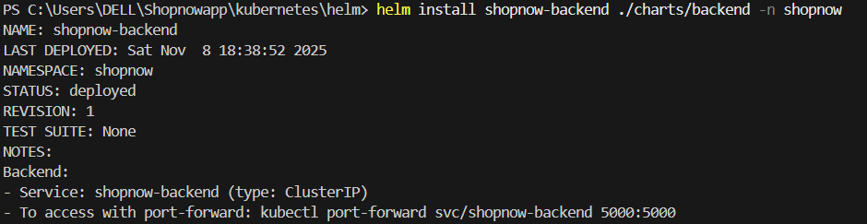

Frontend:
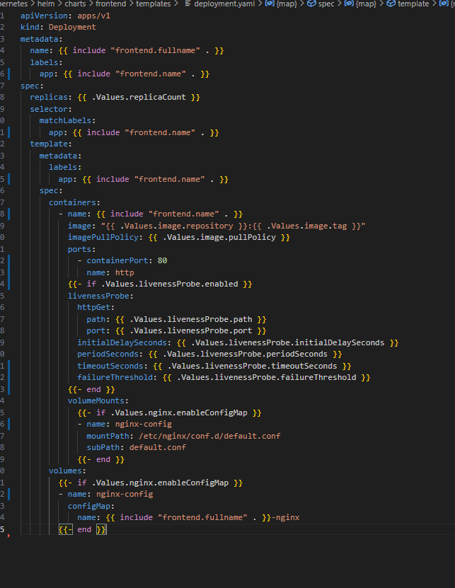
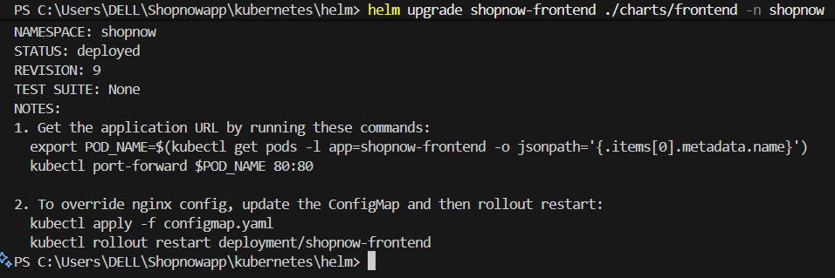

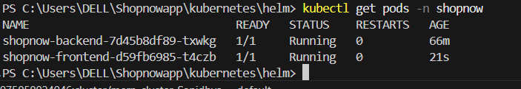

Git repo
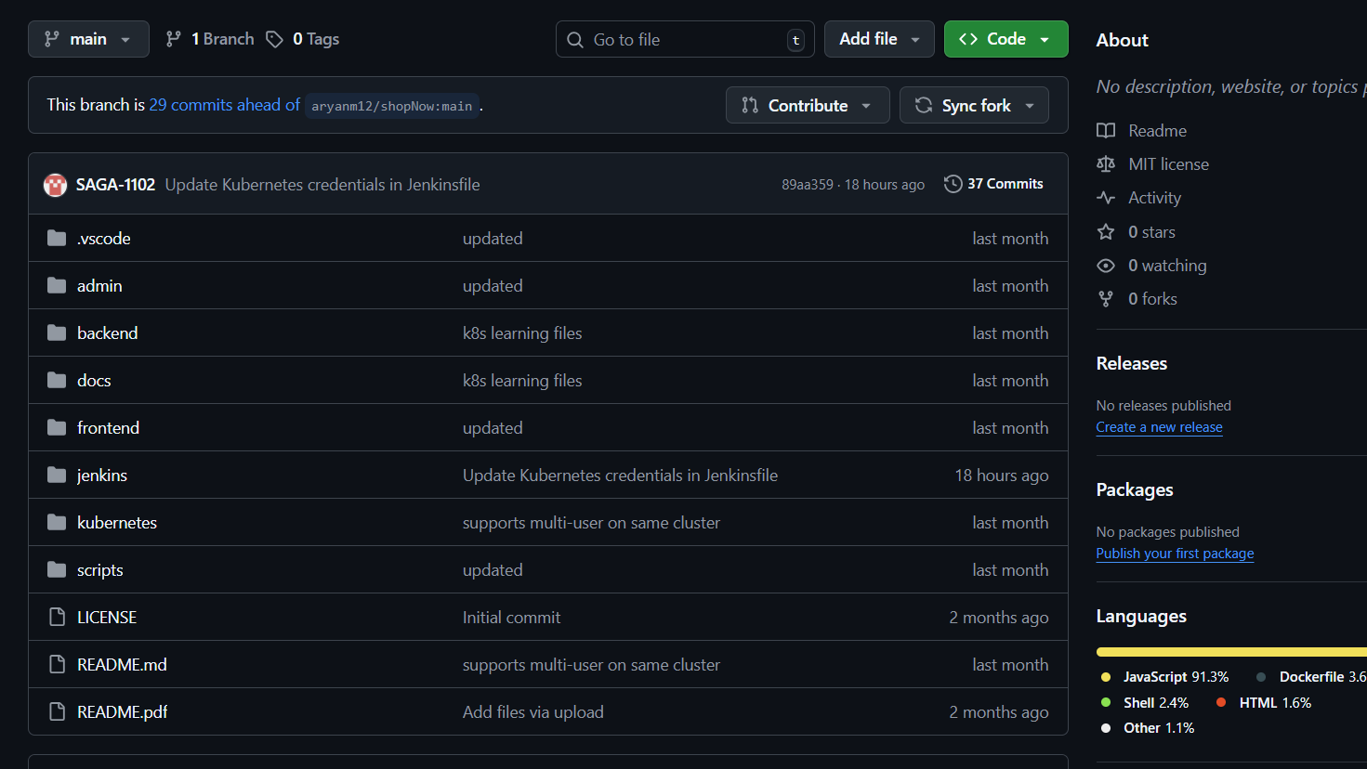

CI/CD pipeline
